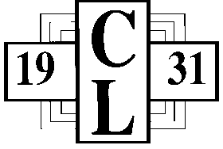
The Charity League of Martinsville and Henry County
c/o Community Foundation Serving Western VA

Confidential Information on Student
To be completed by student’s guidance counselor.
Please complete and submit by February 14, 2020
- Full Name of Student: __________________________________________________
- Parents or Guardians:
Father’s Name: ________________________________________________________
Mother’s Name: _______________________________________________________
- Any background information on family or guardian that might help us in our decision: __________________________________________________________
_______________________________________________________________________
- Special personal characteristics, skills and aptitudes of students: _________
________________________________________________________________________________________________________________________________________________
- What is student’s motivation, maturity, character, and ability to set and pursue realistic goals? Overall potential as a college or vocational student? ________________________________________________________________________________________________________________________________________________________________________________________________________________________

Name of person completing this form: __________________________________
Position/Title: __________________________________________________________
Signature: _____________________________________________________________

